SECTION TOPIC NAME (see file “Subjects”)

INCORPORATED EOSIN Y–GRAPHENE NANOCOMPOSITE: AN EFFICIENT VISIBLE LIGHTE ACTIVE PHOTOCATALYST
Ahmad Ali Kashmeri^{a, c}, Faisal Nawaz^{c}*, Muhammad Yousaf^{a, c}, Ahsan Shameem^{a, c}, Muhammad Shabir Mahr^{b}, Javed Iqbal^{a, c}**,
Muhammad Shafique^{b}
ª Department of Chemistry, University of Agriculture Faisalabad, 38000 Faisalabad, Pakistan
^{b} Department of Physics, University of Agriculture Faisalabad, 38000 Faisalabad, Pakistan
^{c} Punjab Bioenergy Institute, University of Agriculture Faisalabad, 38000 Faisalabad, Pakistan
*e-mail:faisalnawaz1983@gmail.com
**e-mail: javed.iqbal@uaf.edu.pk

Received ; revised ; accepted

Abstract–A novel graphene supported Mn-doped eosin Y based nanocomposite has been successfully prepared by hydrothermal method. Eosin Y–grapheme nanocomposite acts uniquely as a metal free visible light photocatalyst without TiO₂ or Bismuth Vanadate and incorporation of Mn further enhances the activity of the composite. Photocatalyst was active under visible light and photocatalytic activity strongly depends on pH of the degrading dye solutions.
Keywords: graphene oxide, reduced-graphene oxide, manganese, nanocomposite, photocatalyst, methylene blue, dye-degradation
Correct writing
is paid to green supercritical fluid (SCF)
from poly-D,L-lactide (PDLLA)
the density functional theory (DFT), thermogravimetric (TGA/DTA)
mechanical activation (MA)
at temperature T = 293 K, a = 3.0553 Å, c = 13.6459 Å, c/a = 4.466

effect ²T_{g} × e_{g}
constant k = (9.6 ± 3.8) × 10⁻¹¹ cm³ molecules^{–1} s^{–1}
calcium aluminate C12A7 (12CaO ⋅ 7Al₂O₃)
at 500°C, at temperatures of 180 to 240°C, Θ = 157 and 153 K, (1; 2.5%)
for 0.5–1 h, of φ ≤ +5 V, of M₀ = 9, to 33 vol % at φ = 10
structurally ordered Bi₂Se₃ (0001)
of 1,1-diamino-2,2-dinitroethylene (FOX-7)
with nitrate [Fe^{III}(3-OMe-Sal₂trien)]NO₃ ⋅ H₂O(I)
of ceramic solid solutions CuCr₁ _{– x}Mg_{x}O₂ (x = 0–0.013)
Ni + Al mixtures
the Mg–O–Al gel
of the reaction H + HN₂ → HN₂
carbohydrides TiC_{0.45}H_{1.07–1.17} (the content of H₂ is 1.97–2.17 wt %)
(30–70% H₂ + 70–30% C₂H₆ (and C₂H₄))
between Ca 3d and O 2p orbits
atom on CH (001)
in the B3LYP/6-31G(d)
from 7.145 to 5.364 (eV)

INTRODUCTION
Major problem of the modern age is the environmental pollution such as water pollution, air pollution, land pollution and noise pollution etc. Among all these, water pollution is the main problem of the modern times, because of rapid industrialization age (such as paint, textile, cosmetics and food industries) that uses harmful chemicals such as dyes which are released into the water without any treatment. These dyes are very toxic to all life forms and are non-biodegradable [1]. Therefore, it is very important to degrade these industrial dye molecules before discharging into the water. For this purpose different conventional methods are being used to degrade organic dye molecules but these have proven to be ineffective [2]:
Scheme 1. Mechanism for synthesis of asymmetric PNS pincer ligand

In this work, novel eosin Y Mn doped reduced graphene oxide nanocomposites were synthesized by hydrothermal method and were characterized by X-ray diffraction (XRD), Fourier transform infrared spectroscopy (FTIR) and scanning electron microscope/energy-dispersive X-ray spectroscopy (SEM/EDX).
Rout one: in first step thiol group attacked to carbon atom and next phosphorus group attacked in second step, rout two: in first step phosphorus group attacked to carbon atom and next thiol group in second step (Scheme 1). The optimized structures of the TSs as well as lithium diisopropylphosphanide and sodiumthiolates were atracked are depicted in Fig. 1 and 2, respectively.
According to data, in the first step, lithium diisopropylphosphanide attacked to carbon atom ∆G₁≠ and k₁ are 26.05 kcal/mol and 4.86 × 10⁻⁷ s^{–1}, respectively. But when, the sodiumthiolates are said in Table 1 attracked to precursor, the rate constant is highest than lithium diisopropylphosphanide. In the second step, at rout 1 we assumed that thiols such as ethanethiol, (4-aminophenyl)methanethiol, and propane-2-thiol fixed and lithiumdiisopropylphosphanide was attacked to carbon atom.

EXPERIMENTAL
Materials
All chemical reagents such as graphite powder, sulfuric acid, KMnO₄, H₃PO₄, N₂H₄, NaBH₄, KOH and H₂O₂ were purchased from Dae Jung South Korea and were used without further purification (Fig. 3a–3c).

Preparation of reduced graphene oxide
Graphene based catalyst were prepared by Hummer’s method which is highly productive, cost effective, energy saving and fuel efficient [3]. The BSA with 98% purity; from Sigma-Aldrich, Germany; was dissolved in 20 mM sodium phosphate buffer (mix two solution of Na₂HPO₄ and NaH₂PO₄) at pH = 7.40 and stored in dark at 4ºC. The concentration of the BSA was determined spectrophotometrically considering the extinction coefficient of 43824 M^{–1} cm^{–1} at 280 nm [4].
For fluorescence titration experiments, BSA solution (2.5 ml, 7 μM in 20 mM sodium phosphate buffer pH = 7.40) in a quartz cuvette was titrated with various amounts of 0.1 mM solution of both monoazo dyes (Fig. 2a). The fluorescence intensity of BSA with the inner filter effect is corrected using the following Eq. 1 [5]:
$\frac{x_{tip}}{L}=\frac{2Θ_{1}[\exp\left(σ_{2}τ\right) - 1]}{\left(σ_{2} - σ_{1}\right)\exp\left(σ_{2}τ\right) + (σ_{2} + σ_{1})}$ , (1)
where σ₁ is the corrected fluorescence intensity and σ₂ is the observed fluorescence intensity in experiment, θ₁ and θ₂ are the totality of the absorbance of all components at the excitation wavelength (τ).

CONCLUSIONS
Eosin Y–Mn/RGO nanocomposites were fabricated by simple hydrothermal method.
ACKNOWLEDGEMENTS
The authors acknowledge the financial and technical support from Punjab Bio-energy Institute (PBI) located at University of Agriculture Faisalabad (UAF), Pakistan funded by Govt. of the Punjab, Pakistan. The authors also acknowledge the technical support from Department of Chemistry, University of Agriculture Faisalabad, Pakistan.

REFERENCES
In the list of references, if possible, provide references with the indication of the identifier of the digital object (doi).
- R. Criegee and G. Wenner, Justus Liebigs Ann. Chem. 564, 9 (1949).
https://doi.org/10.1002/jlac.19495640103
- W. Chao, J. T. Hsieh, C. H. Chang, and J. J. M. Lin, Science 347, 751 (2015).
https://doi.org/10.1126/science.1261549
- B. Long, J. L. Bao, and D. G. Truhlar, J. Am. Chem. Soc. 138, 14409 (2016).
https://doi.org/10.1021/jacs.6b08655
- M. C. Smith, C.H. Chang, W. Chao, et al., J. Phys. Chem. Lett. 6, 2708 (2015).
https://doi.org/10.1021/acs.jpclett.5b01109
- L. C. Lin, H. T. Chang, C. H. Chang, et al., Phys. Chem. Chem. Phys. 18, 4557 (2016).
https://doi.org/10.1039/C5CP06446E
- C. A. Taatjes, O. Welz, A. J. Eskola, et al., Science 340, 177 (2013).
https://doi.org/10.1126/science.1234689
- L. Sheps, A. M. Scully, and K. Au, Phys. Chem. Chem. Phys. 16, 26701 (2014).
https://doi.org/10.1039/C4CP04408H
- O. Welz, A. J. Eskola, L. Sheps, et al., Angew. Chemie Int. Ed. 53, 4547 (2014).
https://doi.org/10.1002/anie.201400964
- C. A. Taatjes, D. E. Shallcross, and C. J. Percival, Phys. Chem. Chem. Phys. 16, 1704 (2014).
https://doi.org/10.1039/c3cp52842a
- E. S. Foreman, K. M. Kapnas, and C. Murray, Angew. Chemie Int. Ed. 55, 10419 (2016).
https://doi.org/10.1002/anie.201604662
- R. Chhantyal-Pun, M. R. McGillen, J. M. Beames, et al., Angew. Chemie Int. Ed. 56, 9044 (2017).
https://doi.org/10.1002/anie.201703700
- M. A. H. Khan, C. J. Percival, R. L. Caravan, C. A. Taatjes, and D. E. Shallcross, Environ. Sci. Process. Impacts 20, 437 (2018).
https://doi.org/10.1039/C7EM00585G
- M. Kanakidou, J. H. Seinfeld, S. N. Pandis, et al., Atmos. Chem. Phys. 5, 1053 (2005).
https://doi.org/10.5194/acp-5-1053-2005
- M. Hallquist, J. C. Wenger, U. Baltensperger, et al., Atmos. Chem. Phys. 9, 5155 (2009).
https://doi.org/10.5194/acp-9-5155-2009
- C. A. Taatjes, M. A. H. Khan, A. J. Eskola, et al., Environ. Sci. Technol. 53, 1245 (2019).
https://doi.org/10.1021/acs.est.8b05073
- J. T. Herron, R. I. Martinez, and R. E. Huie, Int. J. Chem. Kinet. 14, 225 (1982).
https://doi.org/10.1002/kin.550140303
- Z. Wang, Y. A. Dyakov, and Y. J. Bu, Phys. Chem. A 123, 1085 (2019).
https://doi.org/10.1021/acs.jpca.8b11908
- Y. A. Dyakov, S. O. Adamson, P. K. Wang, et al., Russ. J. Phys. Chem. B 15, 559 (2021).
https://doi.org/10.1134/S1990793121030040
- H. L. Huang, W. Chao, and J. J. M. Lin, Proc. Natl. Acad. Sci. 112, 10857 (2015).
https://doi.org/10.1073/pnas.1513149112
- B. Behera, K. Takahashi, and Y. P. Lee, Phys. Chem. Chem. Phys. 24, 18568 (2022).
https://doi.org/10.1039/D2CP01053D
- R. L. Mauldin III, T. Berndt, M. Sipilä, et al., Nature 488, 193 (2012).
https://doi.org/10.1038/nature11278
- D. Stone, K. Au, S. Sime, et al., Phys. Chem. Chem. Phys. 20, 24940 (2018).
https://doi.org/10.1039/C8CP05332D
- Y. Fang, F. Liu, V. P. Barber, et al., J. Chem. Phys. 144, 061102 (2016).
https://doi.org/10.1063/1.4941768
- N. M. Kidwell, H. Li, X. Wang, J. M. Bowman, and M. I. Lester, Nat. Chem. 8, 509 (2016).
https://doi.org/10.1038/nchem.2488
- X. Wang and J. M. Bowman, J. Phys. Chem. Lett. 7, 3359 (2016).
https://doi.org/10.1021/acs.jpclett.6b01392
- T. L. Nguyen, L. McCaslin, M. C. McCarthy, and J. F. Stanton, J. Chem. Phys. 145, 131102 (2016).
https://doi.org/10.1063/1.4964393
- X. Zhou, Y. Liu, W. Dong, and X. Yang, J. Phys. Chem. Lett. 10, 4817 (2019).
https://doi.org/10.1021/acs.jpclett.9b01740
- Climate Change 2014: Synthesis Report, Ed. by R.K. Pachauri and L.A. Meyer (IPCC, Geneva, 2014).
- W. Choi, S. Kim, W. B. Grant, et al., J. Geophys. Res. Atmos. 107, 8209 (2002).
https://doi.org/10.1029/2001JD000644
- P. R. Nair and M. Kavitha, Int. J. Remote Sens. 41, 8380 (2020).
https://doi.org/10.1080/01431161.2020.1779376
- A. Shinbori, Y. Otsuka, T. Sori, et al., Earth Planets Sp. 74, 106 (2022).
https://doi.org/10.1186/s40623-022-01665-8
- P. K. Wang, J. Geophys. Res. Atmos. 108, 4194 (2003).
https://doi.org/10.1029/2002JD002581
- N. V. Bakhmetieva and I. N. Zhemyakov, Russ. J. Phys. Chem. B 16, 990 (2020).
https://doi.org/10.1134/S1990793122050177
- O. P. Borchevkina, S. O. Adamson, Y. A. Dyakov, et al., Atmosphere 12, 1116 (2021).
https://doi.org/10.3390/atmos12091116
- O. P. Borchevkina, Y. A. Kurdyaeva, Y. A. Dyakov, et al., Atmosphere 12, 1384 (2021).
https://doi.org/10.3390/atmos12111384
- S. Mohammad, P. K. Wang, and Y. L. Chou, Russ. J. Phys. Chem. B 16, 549 (2022).
https://doi.org/10.1134/S1990793122030198
- G. V. Golubkov, S. O. Adamson, O. P. Borchevkina, et al., Russ. J. Phys. Chem. B 16, 508 (2022).
https://doi.org/10.1134/S1990793122030058
- J. Kesselmeier and M. J. Staudt, Atmos. Chem. 33, 23 (1999).
https://doi.org/10.1023/A:1006127516791
- K. Sindelarova, C. Granier, I. Bouarar, et al., Atmos. Chem. Phys. 14, 9317 (2014).
https://doi.org/10.5194/acp-14-9317-2014
- H. Levy, Science 173, 141 (1971).
https://doi.org/10.1126/science.173.3992.141
- J. Lelieveld, F. J. Dentener, W. Peters, and M. C. Krol, Atmos. Chem. Phys. 4, 2337 (2004).
https://doi.org/10.5194/acp-4-2337-2004
- J. M. Beames, F. Liu, L. Lu, and M. I. Lester, J. Chem. Phys. 138, 244307 (2013).
https://doi.org/10.1063/1.4810865
- L. Sheps, J. Phys. Chem. Lett. 4, 4201 (2013).
https://doi.org/10.1021/jz402191w
- F. Liu, J. M. Beames, A. M. Green, and M. I. Lester, J. Phys. Chem. A 118, 2298 (2014).
https://doi.org/10.1021/jp412726z
- W. L. Ting, Y. H. Chen, W. Chao, M. C. Smith, and J. J. M. Lin, Phys. Chem. Chem. Phys. 16, 10438 (2014).
https://doi.org/10.1039/C4CP00877D
- K. Samanta, J. M. Beames, M. I. Lester, and J. E. Subotnik, J. Chem. Phys. 141, 134303 (2014).
https://doi.org/10.1063/1.4894746
- Y. P Lee, J. Chem. Phys. 143, 020901 (2015).
https://doi.org/10.1063/1.4923165
- A. W. L. Ting and J. J. M. Lin, J. Chinese Chem. Soc. 64, 360 (2017).
https://doi.org/10.1002/jccs.201700049
- V. J. Esposito, O. Werba, S. A. Bush, B. Marchetti, and T. N. V. Karsili, Photochem. Photobiol. 98, 763 (2022).
https://doi.org/10.1111/php.13560
- M. Larsson and A. E. Orel, Dissociative Recombination of Molecular Ions (Cambridge University Press, Cambridge, 2008).
- M. F. Lin, C. M. Tzeng, Y. A. Dyakov, and C. K. Ni, J. Chem. Phys. 126, 241104 (2007).
https://doi.org/10.1063/1.2751150
- Y. A. Dyakov, A. M. Mebel, S. H. Lin, Y.T. Lee, and C. K. Ni, J. Phys. Chem. A 111, 9591 (2007).
https://doi.org/10.1021/jp0740649
- C. M. Tseng, Y. A. Dyakov, H. C. Huang, et al., J. Chem. Phys. 133, 074307 (2010).
https://doi.org/10.1063/1.3474992
- A. M. Mebel, T. S. Zyubina, Y. A. Dyakov, A. D. Bandrauk, and S. H. Lin., Int. J. Quantum Chem. 102, 506 (2005).
https://doi.org/10.1002/qua.20436
- Y. A. Dyakov, C. K. Ni, S. H. Lin, Y. T. Lee, and A. M. Mebel., J. Phys. Chem. A 109, 8774 (2005).
https://doi.org/10.1021/jp053218m
- Y. A. Dyakov, Y. C. Ho, W. H. Hsu, and C. K. Ni, Chem. Phys. 515, 543 (2018).
https://doi.org/10.1016/j.chemphys.2018.09.019
- Y. A. Dyakov, S. Toliautas, L. I. Trakhtenberg, and L. Valkunas, Chem. Phys. 515, 672 (2018).
https://doi.org/10.1016/j.chemphys.2018.07.020
- Y. A. Dyakov, S. O. Adamson, P. K. Wang, et al., Russ. J. Phys. Chem. B 16, 543 (2022).
https://doi.org/10.1134/S1990793122030149
- C. H. Hsu, M. T. Tsai, Y. A. Dyakov, and C. K. Ni, Int. Rev. Phys. Chem. 31, 201 (2012).
https://doi.org/10.1080/0144235X.2012.673282
- M. Kumar and J. S. Francisco, J. Phys. Chem. Lett. 8, 4206 (2017).
DOI: 10.1021/acs.jpclett.7b01762
- K. Xu, W. Wang, W. Wei, et al., Phys. Chem. A 121, 7236 (2017).
https://doi.org/10.1021/acs.jpca.7b05858
- Y. A. Dyakov, S. O. Adamson, P. K. Wang, et al., Russ. J. Phys. Chem. B 15, 782 (2021).
https://doi.org/10.1134/S1990793121050134
- Y. A. Dyakov, S. O. Adamson, G. V. Golubkov, et al., Atoms 11, 157 (2023).
https://doi.org/10.3390/atoms11120157
- A. D. Becke, J. Chem. Phys. 96, 2155 (1992).
https://doi.org/10.1063/1.462066
- A. D. Becke, J. Chem. Phys. 97, 9173 (1992).
https://doi.org/10.1063/1.463343
- A. D. Becke, J. Chem. Phys. 98, 5648 (1993).
https://doi.org/10.1063/1.464913
- C. Lee, W. Yang, and R. G. Parr, Phys. Rev. B 37, 785 (1988).
https://doi.org/10.1103/PhysRevB.37.785
- M. J. Frisch, G. W. Trucks, H. B. Schlegel, G. E. Scuseria, M. A. Robb, J. R. Cheeseman, G. Scalmani, V. Barone, G. A. Petersson, H. Nakatsuji, X. Li, M. Caricato, A. V. Marenich, J. Bloino, B. G. Janesko, R. Gomperts, B. Mennucci, H. P. Hratchian, J. V. Ortiz, A. F. Izmaylov, J. L. Sonnenberg, D. Williams-Young, F. Ding, F. Lipparini, F. Egidi, J. Goings, B. Peng, A. Petrone, T. Henderson, D. Ranasinghe, V. G. Zakrzewski, J. Gao, N. Rega, G. Zheng, W. Liang, M. Hada, M. Ehara, K. Toyota, R. Fukuda, J. Hasegawa, M. Ishida, T. Nakajima, Y. Honda, O. Kitao, H. Nakai, T. Vreven, K. Throssell, J. A. Montgomery, J. E. Peralta, F. Ogliaro, M. J. Bearpark, J. J. Heyd, E. N. Brothers, K. N. Kudin, V. N. Staroverov, T. A. Keith, R. Kobayashi, J. Normand, K. Raghavachari, A. P. Rendell, J. C. Burant, S. S. Iyengar, J. Tomasi, M. Cossi, J. M. Millam, M. Klene, C. Adamo, R. Cammi, J. W. Ochterski, R. L. Martin, K. Morokuma, O. Farkas, J. B. Foresman, D. J. Fox, Gaussian, Inc., Wallingford CT. Gaussian 09, Revision A.02.
- H. Eyring, S. H. Lin, and S. M. Lin, Basic chemical kinetics (JohnWiley & Sons, New York, 1980).
- P. J. Robinson and K. A. Holbrook, Unimolecular reactions (JohnWiley & Sons, New York, 1972).
- J. I. Steinfeld, J. S. Francisco, and W. L. Hase, Chemical kinetics and dynamics (Prentice Hall, Upper Saddle River, 1999).
- V. V. Kislov, T. L. Nguyen, A. M. Mebel, S. H. Lin, and S. C. Smith, J. Chem. Phys. 120, 7008 (2004).
https://doi.org/10.1063/1.1676275
- J. M. Nugent and C. S. Bretherton, Geophys. Res. Lett. 50, e2023GL105083 (2023).
https://doi.org/10.1029/2023GL105083
- C. Tang, D. Liu, H., Wei, et al., J. Geophys. Res.: Space Phys. 121, 7245 (2016).
https://doi.org/10.1002/2016JA022538
- S. M. Smith, M. Setvák, Y. Beletsky, J. Baumgardner, and M.J. Mendillo, J. Geophys. Res. Atmos. 125, e2020JD033381 (2020).
https://doi.org/10.1029/2020JD033381
Table 1. Evaluation results of drilling fluid rheological properties
Additives | AV,  mPa ∙ s | PV,  mPa ∙ s | YP/Pa,  Pa/mPa ∙ s | YP/PV,  Pa/mPa ∙ s | Ρ,  g/cm³ | FL,  mL | μ
Blank | 4.95 | 2.8 | 2.1793 | 0.7848 | 1.008 | 13.7 | 0.0524
0.1% ASS-8 | 7.50 | 3.5 | 4.0880 | 1.1680 | 1.015 | 17.9 | 0.0342
0.3% KD-03 | 4.9 | 2.8 | 2.1462 | 0.7665 | 1.018 | 11.0 | 0.0875
0.1% ASS-8 + 0.3% KD-03 | 9.7 | 4.4 | 5.4166 | 1.2310 | 1.021 | 13.7 | 0.1051
0.1% PAM | 8.0 | 4.2 | 3.8836 | 0.9247 | 1.022 | 12.0 | 0.0699
0.1% ASS-8 + 0.1% PAM | 12.0 | 3.6 | 8.5848 | 2.3847 | 1.024 | 22.4 | 0.0699
1.0% Modified starch | 6.0 | 4.0 | 2.0440 | 0.5110 | 1.022 | 7.5 | 0.0699
0.1% ASS-8 + 1.0% Modified Starch | 11.9 | 4.8 | 7.2562 | 1.5117 | 1.030 | 6.2 | 0.0612

Table 2. Corrosion rate and inhibitor efficiencies for various
concentrations of aniline/N,N-dimethylaniline in 5% HCl at 303 K
Inhibitor | Concentrations,  g · L^{–1} | W_{corr,}  g · m^{–2} · h⁻¹ | E_{w}, %
Blank | 0 | 2.43 | –
Aniline | 0.1 | 1.89 | 22.3
 | 0.5 | 1.38 | 43.2
 | 1.0 | 0.98 | 59.7
 | 1.5 | 0.94 | 61.3
 | 2.0 | 0.90 | 63.0
N,N-dimethylaniline | 1.0 | 1.93 | 20.6
 | 1.5 | 1.81 | 25.5
 | 2.0 | 1.74 | 28.4

Table 3. The calculated values of ΔG₂≠ and k₂ for synthesis of asymmetric PNS pincer ligand in secondary step
Rout 2 |  |  |  | Step two |  | Rout 1 |  |  |  | Step two
T∆S≠, kcal/mol | ∆H≠, kcal/mol | K₂, s^{–1} | ∆G₂≠, kcal/mol | RSNa attacked |  | T∆S≠, kcal/mol | ∆H≠, kcal/mol | K₂^{b}, s^{–1} | ∆G₂≠, kcal/mol | P^{i}Pr₂Li attacked
–24.628 | 24.629 | 1.25 ∙ 10⁺¹² | 0.95 | Ethanethiol |  | –14.65 | +16.94 | 2.97 ∙ 10⁺¹⁴ | –2.29 | Ethanethiol
–24.624 | 24.629 | 2.22 ∙ 10⁺¹² | 4.7 | Propane-2-thiol |  | 14.24 | 16.17 | 3.08 ∙ 10^{–10} | 30.41 | Propane-2-thiol
14.43- | +9.96 | 3.27 ∙ 10⁺⁹ | 4.47 | (4-Aminophenyl)methanethiol |  | 96.633 | +96.635 | 1.82 ∙ 10⁺¹⁴ | –2.00 | Cyclopentanethiol

Captions for figures to the article Ahmad Ali Kashmeri et al.

Fig. 1. Langmuir’s adsorption plots for steel in 5% HCl containing different concentrations of aniline/N,N-dimethylaniline at different temperature. (a) Aniline: (1) 303 K, (2) 323 K, (3) 343 K; (b) diphenilamine; (1) 303 K, (2) 323 K, (3) 343 K.
Fig. 2. The screening of the concentration of inhibitor: (1) 0.1% ASS-8, (2) 0.3% ASS-8, (3) 0.4% ASS-8, (4) 0.5% ASS-8, (5) 1% ASS-8, (6) 1.5% ASS-8, (7) 4% KCl, (8) distilled water.
Fig. 3. The effect of ASS-8 concentration on anti-swelling rate.
Fig. 4. The distribution of clay particle size in different suspensions: (1) un-hidrated + 0.2% ASS-8, (2) hidrated + 0.2% ASS-8, (3) un-hidrated, (4) hidrated.
Fig. 5. The TGA of the bentonite treated with different methods: (1) ASS-8, (2) blank.
Fig. 6. UV patterns of SO series: (1) represents SO, (2) represents SO-1, (3) represents SO-2, (4) represents SO-3, (5) represents SO-4).
Fig. 7. (a) TSs structures in first step for, (b) ethanthiol, propane-2-thiol: (1) (4-aminophenyl)methanethiol, (2) (4-nitrophenyl)methanethiol and second step for, (3) ethanthiol, (4) propane-2-thiol.

In this sample, the figures do not correspond to the captions to the figures. The drawings themselves are samples of design.

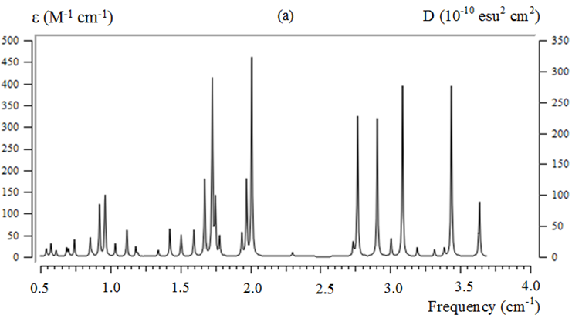
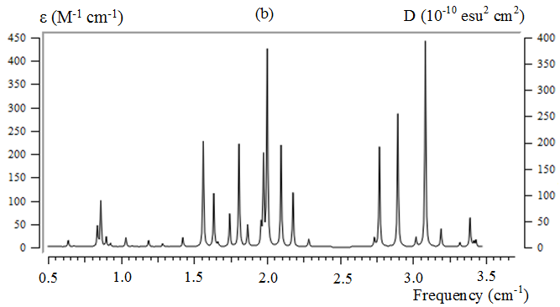

Fig. 1
Kashmeri et al.

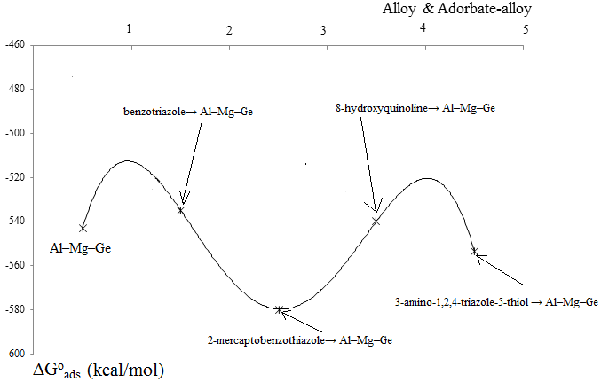

Fig. 2
Kashmeri et al.

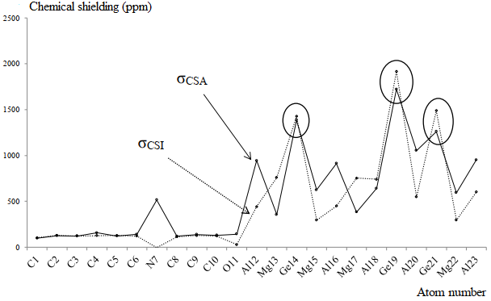
Fig. 3
Kashmeri et al.
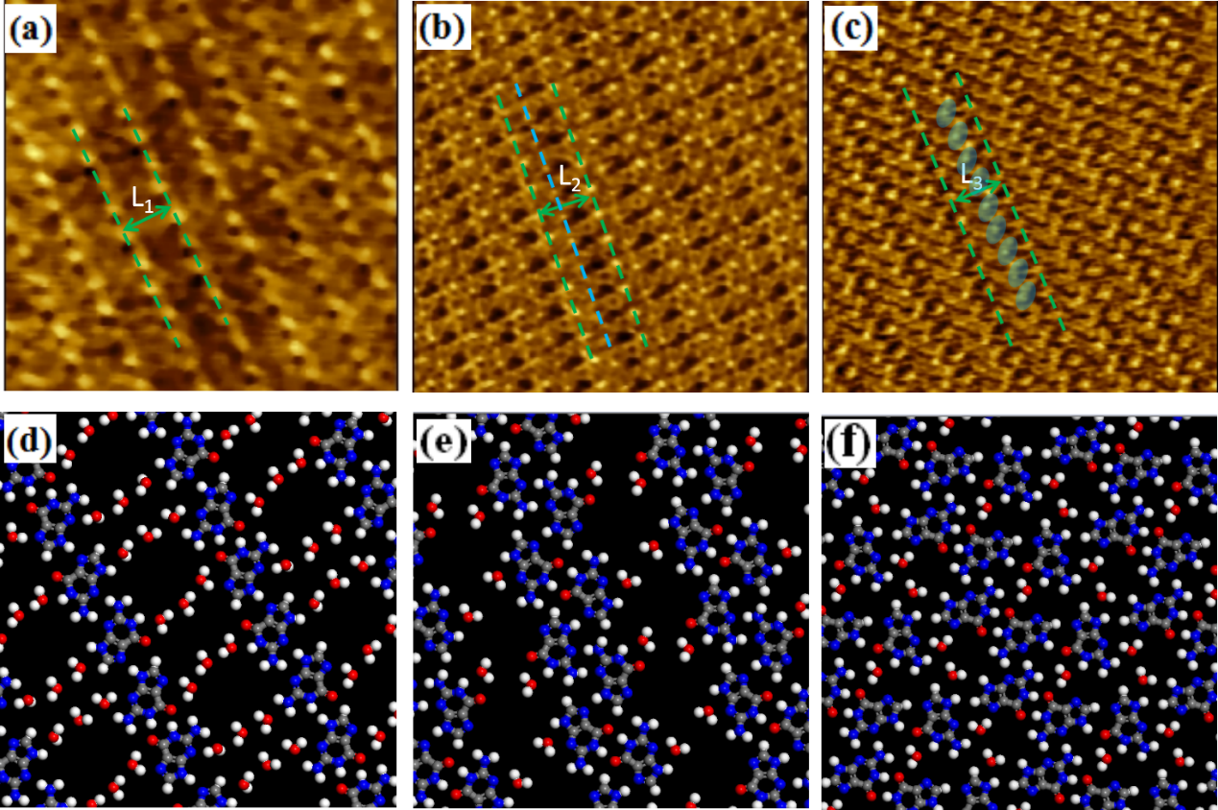
Fig. 4
Kashmeri et al.
127 LUMО (Е = –0.19347 еV)
(24)
Fig. 4.
Kashmeri et al.

Fig. 5
Kashmeri et al.

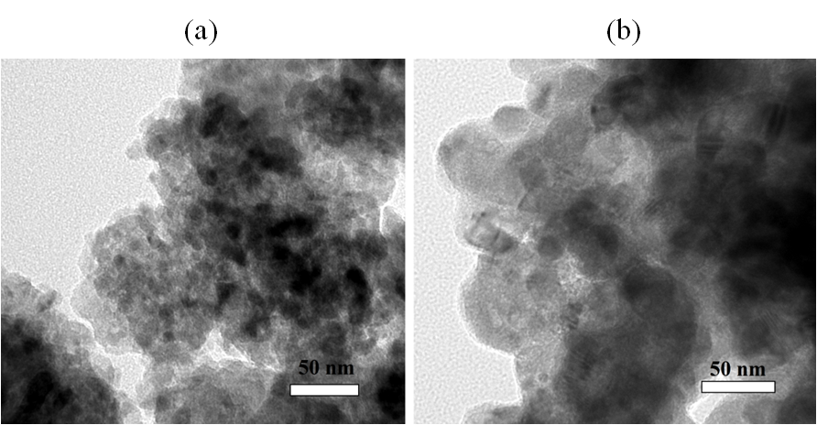
Fig. 6
Kashmeri et al.

Fig. 7
Kashmeri et al.

1
L
p₁ – w
p₂ – w
p₁ – w
w
w
p₂ – w

w
w
Lane 1
Lane 2
α
α
β
β

Fig. 8
Kashmeri et al.

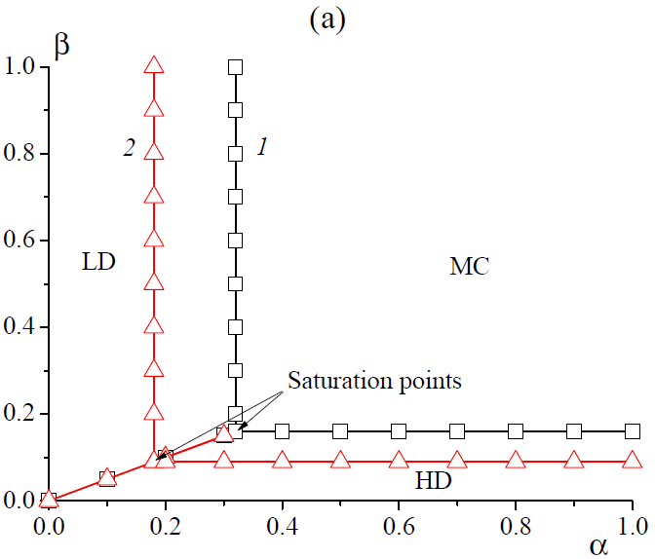
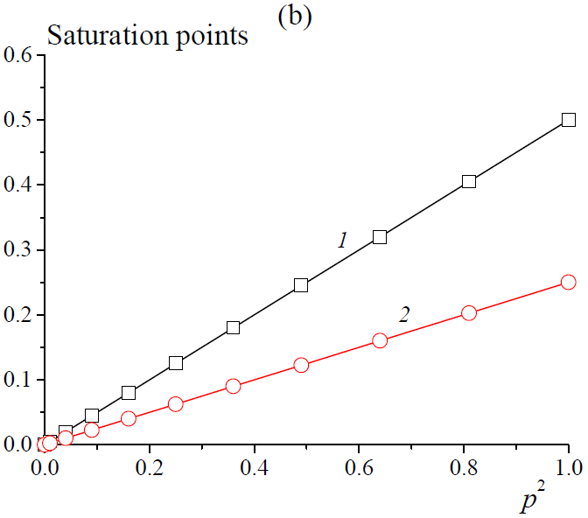
Fig. 9
Kashmeri et al.

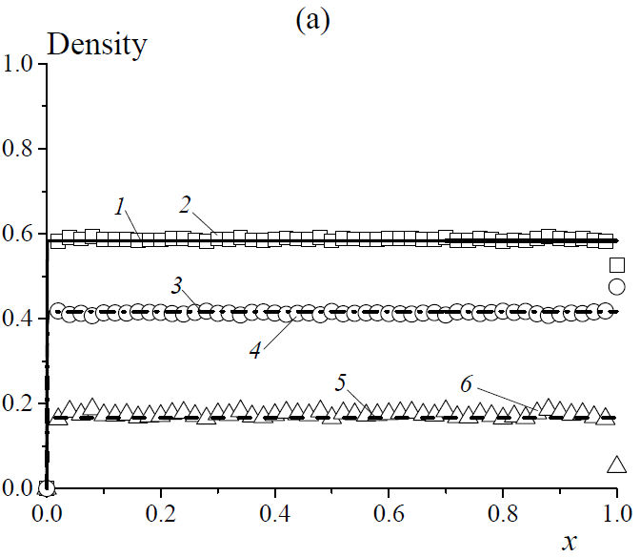
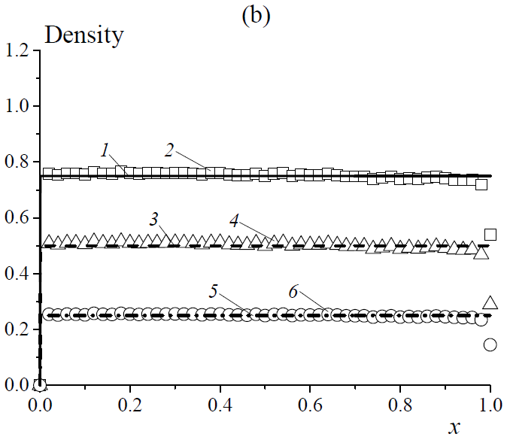
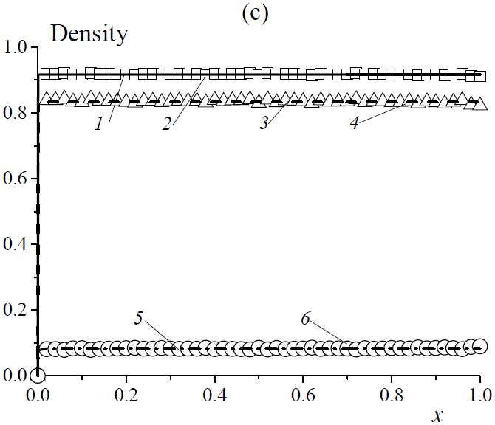
Fig. 10
Kashmeri et al.
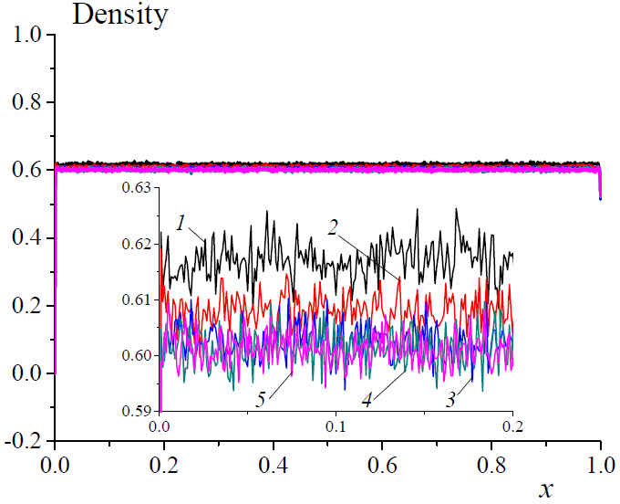
Fig. 11
Kashmeri et al.

